Name
Institution
Course
Instructor
Date

Orland International Airport(MCO)
Orlando international airport is an airport in Florida which all the cities in Florida can access. The United States Airforce owned the airport until 1978. A seven-member board governs the Greater Orlando Aviation Authority(GOAA) which currently owns the airport. The airport covers a large area of about 23 square miles which makes it the third-largest airport in the United States. The airport is one of the busiest airports in the United States accommodating over 30 million travelers annually. The airport is highly known for its advanced use of modern technology, making it more convenient. The navigation in the airport is simplified with numerous glass walls giving the passenger beautiful panoramic views of the lake and the native Florida vegetation. The airport offers other services, including hotel services via their restaurants, numerous stores and the Hyatt Regency hotel located on the top of the terminal with up to 443 rooms (Authority, 2010).
The airport is also known for its rental car services which makes it the best in the market. There are various rental car companies including major rental car companies which can be easily accessed by the passengers with major car companies such as Alamo, Avis and National partnering in offering the rental car services (Authority, 2010). The airport has daily flights of over 870 flights which carry passengers to different destinations in the United States. Over 94,000 passengers are carried by the 50 different airlines of the airport which serve over 85 destinations in the US. Some of the major destinations of the airlines include the Mexico City, San Diego and even San Francisco. There are major airlines serving the Orlando international airport such as the southwest airlines, the Delta Airlines and JetBlue, American Airlines and The United Airlines.
Security and screening at the Orlando International Airport
The Transportation Security Administration is a United States agency responsible for providing travelling security to public members travelling. Like other major airports, Orlando international airport uses the Registered Traveler program in screening passengers. With the program, passengers queue through screening lanes for background checks. The airport includes pre-checks by the TSA every day in the airport's main checkpoint. Employee screening is also included in the security checks at the airport. Security measures are e enacted to ensure the screening of employees who may bypass the regular screening due to their credentials. Following reported cases of workers smuggling from drugs to firearms into planes, the Orlando international airport has implemented the policy to screen the airport personnel (Skinner, 2018).
Measures of protecting the surrounding environment against;
- Obstruction by obstacles
The Orlando international airport is guided by the policies of the FAA. The Federal Aviation Administration has established various guidelines in airports to solve the problem of limited navigable space. The guidelines of the administration are meant to ensure that height of buildings, trees antennas and other objects provide minimum space for aircraft protection. A notice on the construction of any new structures or reconstruction of the existing ones should be provided to the FAA.
Noise
The Orlando international airport (MCO) has a program for noise abatement which includes various stakeholders in reducing noise and educating the public on the airport’s operations (McConkey, Bolz, & Reuss, 2017). There are numerous voluntary procedures of noise abatement in the airport which have been in use for a long time. The measures include;
- South flow operations favored by the preferential use of runways.
Flow of operations is concentrated on the side with less activity. This is to ensure the airport activities do not interrupt the activity of the members of the local community.
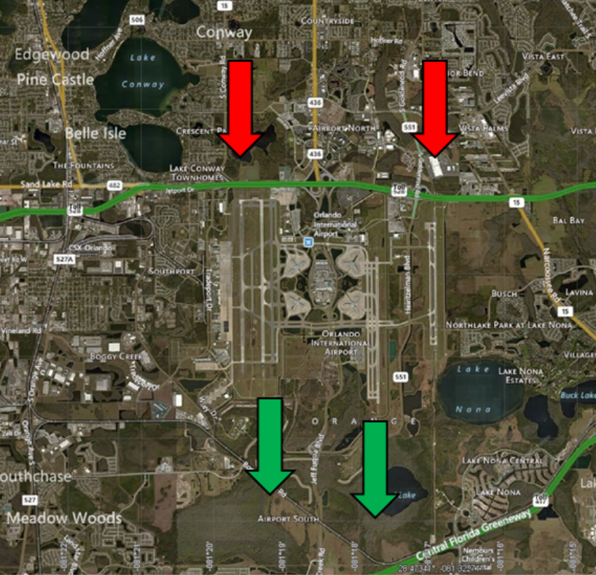
- Major departures are assigned to the northern side with less population with engine run-up designated to reduce noise. This is according to the noise advisory.
Engine run-up
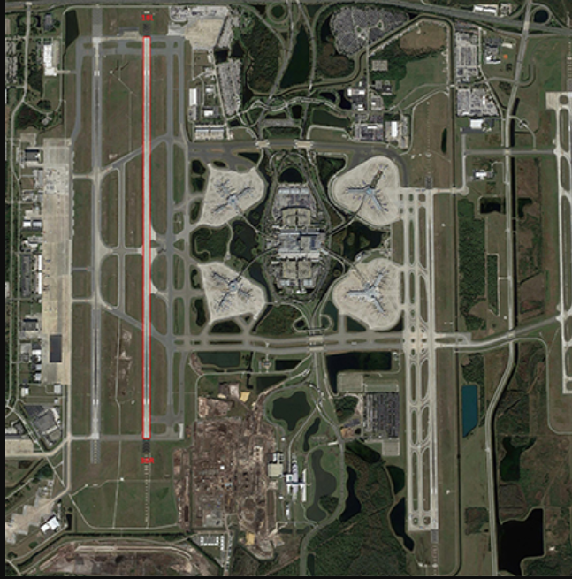
- The approaches regarding helicopter departures at the international airport aim at ensuring minimal flights over areas of residence.
The federal aviation administration plays its role in ensuring that aircraft are separated in the national airspace.
Procedures in operation
The sensitivity of noise from the Orlando international airport to the surrounding communities is considered to be of key importance as much as protection is. There are various voluntary procedures used in noise abatement, including routings of aircraft. If there are favorable conditions, the Federal Aviation Administration conducts the south flow of operations. Airplanes in the airport arrive from the northern side while the departing aircraft use the southern routes. During the night time, the routes used for noise reduction include the north flow operations. Aircraft at night are directed towards the routes which are far away from the surrounding long-established residential areas.
Routing of aircraft is also a significant measure of noise abatement by the Orlando international airport. The FAA controls the traffic of aircraft in the United States. The regulation of flights in the airport helps in ensuring that minimum noise generation by aircraft is achieved.
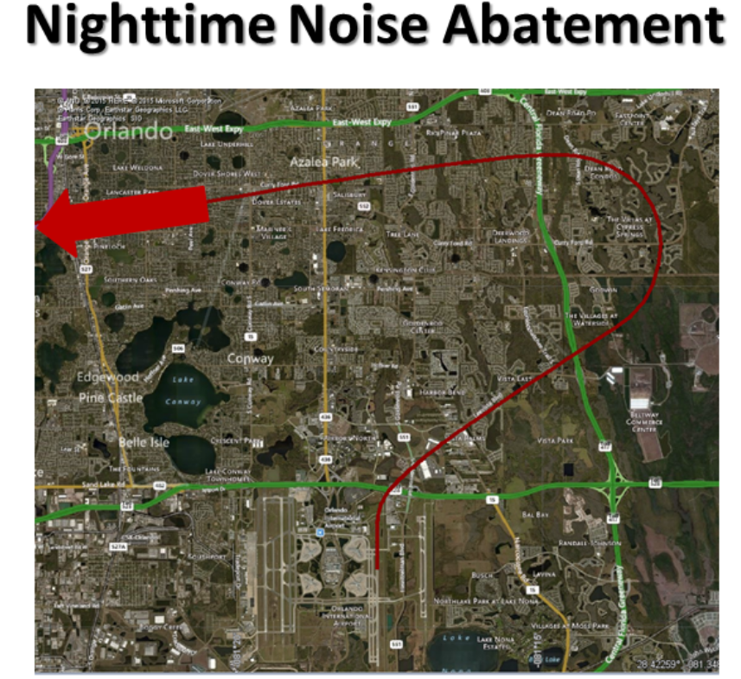
The federal legislation
There are specific standards of certification required for aircraft to meet. The standards are used by the Federal Aviation Administration in regulating the maximum level of noise generated by a sole airplane. The certification standards of noise reduction in the United States are designed at differed stages (Authority, 2010). Airworthy aircraft receive the noise certification if they comply with the required standards. The noise certification has been included in attempts to ensure that the latest technology implemented for noise reduction has been incorporate in designing aircraft. The reduction of noise by the use of the technologies should be realized by the members of the surrounding communities. The advancement in noise abatement technology allows the FAA to always analyze the need for a new standard to be implemented. The implemented new standard depends on the major issues raised by the international community. The Orlando International airport ensures that all these policies are implemented in their operations through the GOAA program of noise reduction (Baik, Trani, Hinze, Swingle, Ashiabor, & Seshadri, 2018).
Land use measures
Land use measures have been implemented in the Orlando International airport according to the provisions of the Greater Orland Aviation Authority(GOAA). There has been the implementation of sound insulation programs in areas with high exposure to noise in the airport. Some specified airspace in the Orlando international airports have been identified for flights which are unobstructed. However, all the flights require some kind of notification due to the growing activity of the aircraft in the airport—the failure to report or give notification before any overflights can lead to complications. There is a noise overlay district in the airport meant to ensure the health and the safety of the members of the public is protected (Li, Eiff, Laffitte, & McDaniel, 2019).

Accident history at the Orlando international airport
There have been numerous cases in the past of crashing aircraft, including accidents at the airport or near the airport. The accidents include aircraft leaving the Orlando international airport and aircraft with their destination at the airport.
Accidents near or at the airport
In March 2001, an airplane with the destination of the Orlando international airport reported an accident. The accident involved the stall of an Embraer EMB-120RT Brasilia as the craft was approaching the Orlando international airport. The investigations established that the accident was probably caused by the flight crew's failure to maintain speed when they encountered severe conditions of icing. The severe conditions led to the crew losing control of the plane and stalling of the plane, which led to structural damages on the aircraft. The plane was reportedly under autopilot control at the height of 18000 before encountering the poor conditions which hindered visibility. The actions by the pilots to control the plane, including turning on ice protection were all unsuccessful. The plane later landed at the west palm beach 12 minutes later but with various damages (Li, & Liang, 2018).
On 2nd July 2000, an accident involving a container loader and a Boeing 737-49 occurred upon arrival of the airplane at the Orlando international airport gate. Investigations by the Federal Aviation Administration established the cause of the accident as captain's failure to observe instructions. The captain was given a signal to stop the plane but failed to stop it as it taxied to the airport's gate which led to the left-wing of the aircraft colliding with equipment on the ground.
A Boeing 737-73V (WL) collapsed when being taxied to maintenance. The aircraft, when being pulled ran out of its runway leading to taxiway excursion. The accident led to a collapse of nose gear at the airport. The accident occurred at night on 11th August 2015.
On 8th August 2019, an aircraft accident occurred involving Airbus A321-211(WL) which experienced tail-strike on its arrival at the Orlando international airport from the Portland International Jetport. The accident led to substantial damages as the plane was repaired later and could resume operations four months later.
Noise and safety issues at the Orlando international airport
Noise complaints against the Orlando international airport have reportedly been rising. The residents living in the nearby communities, despite the FAA efforts to ensure noise abatement standards, still suffer from noise generated from the busy airport. The airport has been reported to be among the top ten busiest airports in the countries recording over 100,000 daily passengers via the airport. This has increased the activities at the airport. Many of the claims from the residents indicate that some of the planes fly at a low altitude, making them louder (McConkey, Bolz, & Reuss, 2017).
There have been various steps taken by the federal aviation administration to ensure that the complaints from the residents are resolved. Since the major complaints are filed by the households directly under the flight path of the airport, the airport is considering changing its flight path. This is viewed as a major way of providing relieving the neighboring communities of the noise from the airport activities. A series of meetings by the FAA and the members of the community have been held to get the resident's input on the major ways of reducing the noise problem. The FAA also has a plan for modernization of the airport with measures to optimize the airport operations.
Jet noise has also been considered a major issue over recent years. The fast-moving jets over the communities on the northern side of the international airport are a major cause of disturbance to the public. Residents though their complaints indicate that the noises may be disruptive such that they may interrupt daily activities. The federal aviation administration has considered the airport as a major source of noise pollution to the surrounding area. The effects of noise pollution mainly include interrupted communications which can be experienced by residents living up to five miles from the Orlando International Airport (McConkey, Bolz, & Reuss, 2017).
Consolidation of flight paths has been considered as a major measure of solving the issue of noise pollution by the federal government. The administration is also considering establishing autopilot programs for flights taking off from the northern side to avoid the change of route by pilots once they take off.
Safety measures are taken at the Orlando international airport.
Following the covid-19 pandemic, the Orlando international airport has implemented a safety policy which has been approved by the GOAA. The CEO of the Greater Orlando Aviation Authority has recently indicated that the recent safety measures are meant to improve the confidence of the members of the public travelling through the airport. The airport's protocols are continuously updated according to the safety policy and the major measures taken to promote social distancing (Baik, Trani, Hinze, Swingle, Ashiabor, & Seshadri, 2018).
Most of the flight schedules by different airlines have been adjusted recently with the airport expecting a high number of flights in the future. This has necessitated the provision of facilities which are safe and secure for the protection of the numerous passengers visiting the airport’s facilities. The airport personnel are expected to adhere to the social distancing rules as directed by the Centers for Disease Control. The social distancing measures also include the use of facial coverings by the personnel under applicable circumstances as protection against the spread of the coronavirus. The airport has authorized the use of different types of facial masks like the medical masks, homemade masks or even industry mask. The facial coverings of any type have been deemed appropriate as much as the covering does not contain any messages or images which may tend to be offensive. All these policies are expected to be observed by every person at the airport with a badge from the GAOO (Le, Le, Parikh, Brooks, Gardellini, & Izurieta, 2020).
Long term sustainability of the airport at the current location
The Orlando international airport is one of the major international airports found in the state of Florida located ten kilometers on the southeast of Downtown Florida. The airport has reported the highest level of activity over the years, making it the busiest airport in Florida as well as the 10th busiest airport among all the airports in the United States. The highest activity was reported in the year 2019, where a number of over 50 million passengers travelled through the airport. The airport is a major operating base for major airlines in the United States including Southwest Airlines, JetBlue as well as Silver airways. The mid-Florida region considers the airport a major gateway. The airport records more than 850 flights on every day with different airlines operating in the airport. There are major international destinations and domestic destinations served by the airport. The airports have been considered to have one of the largest commercial lands in the United States due to the large area of land the airport occupies (Li, Eiff, Laffitte, & McDaniel, 2019).
The air demand forecast indicates growth in demand for air transport over the years. Air activity, according to research, is likely to double before the year 2037. This is due to the growing economies and the identification of new markets in different destinations. Daily individual activities in Florida are in the rise with air transport demand increasing. The middle class have been able to afford the air transport tickets recently due to the decreasing prices of air tickets. This has increased the use of air transport by the middle class, including the working class who constitute a large number of travelers each day. The decrease in the air tickets has increased the accessibility of the tickets to a larger market hence increasing the use of air activity. The need for improved living standards among the working class and the middle class, in general, has led to an increase in the annual rates of passenger traffic over the years. The emerging economies in different countries have led to the development of new air traffic markets with the establishment of new air destinations (Baik, Trani, Hinze, Swingle, Ashiabor, & Seshadri, 2018).
The Orlando international airport can sustain long-term activity with its current location. The airport's location to the Downtown of Florida allows it to serve major markets. A large number of flights through the airport to over 135 different destinations can grow over the years. The airport is doing major innovations on its terminals to sustain the growing number of airport activity.
Public complaints about the airport have limited airport activity over the years. The airport's activity needs regulation according to the noise abatement procedures. The airport is currently undergoing major renovations on its terminals to ensure its activities do not affect the neighboring established communities. The reconstruction plans are also meant to sustain the growing demand for the airport transport. The activities may be limited by the noise abatement procedures, but the routes of the airport have been shifted with planes taking departure routes away from the neighboring communities hence not affecting their daily activities (McConkey, Bolz, & Reuss, 2017).
The efforts put forward by the Orlando international airport have helped in attaining the highest activity in the state. The growing activity in the airport has shown that the airport is adapting to the increased demand for air transport. The airport is a major operating base for major airlines like JetBlue and silver airlines which have all recorded increased activity over the years. The major airlines operating through the airport are always increasing their daily activities. The high number of passengers recorded in 2019 over the 44 different airlines shows the increased number in the activity. The increased activity level in the airport can help the airport sustain the increased demand for airport transport in the long-term (McConkey, Bolz, & Reuss, 2017).
Various factors have a key role in the ability of the airport to sustain the increased air traffic activity with its location. The airport is located in one of the busiest states in the United States. The increased activity has seen the airports effort to put on strategies of sustaining growth in demand for air transport.

References
Authority, G. O. A. (2010). Orlando International Airport. Phase II Expansion, Automated Guideway Transit System, Part. https://www.ifmaorlando.org/docs/Airport_presentation_2014.pdf
Baik, H., Trani, A. A., Hinze, N., Swingle, H., Ashiabor, S., & Seshadri, A. (2018). Forecasting model for air taxi, commercial airline, and automobile demand in the United States. Transportation Research Record, 2052(1), 9-20. https://journals.sagepub.com/doi/abs/10.3141/2052-02
Le, N. K., Le, A. V., Parikh, J., Brooks, J. P., Gardellini, T., & Izurieta, R. (2020). Ecological and health infrastructure factors are affecting the transmission and mortality of COVID-19. https://www.researchsquare.com/article/rs-19504/latest.pdf
Li, K. M., Eiff, G., Laffitte, J., & McDaniel, D. (2019). Land Use Management and Airport Controls. FAA. https://www.spiedigitallibrary.org/conference-proceedings-of-spie/4363/0000/Airport-surface-moving-map-displays--OpEval-2-evaluation-results/10.1117/12.438027.short
Li, Y., & Liang, C. (2018). The analysis of spatial pattern and hotspots of aviation accident and ranking the potential risk airports based on gis platform. Journal of Advanced Transportation, 2018. https://www.hindawi.com/journals/jat/2018/4027498/abs/
McConkey, E., Bolz, E., & Reuss, L. (2017). The impact of low-noise approach procedures on airport capacity. In 1st AIAA, Aircraft, Technology Integration, and Operations Forum (p. 5238). https://arc.aiaa.org/doi/pdf/10.2514/6.2001-5238
Skinner, R. L. (2018). TSA’s Security Screening Procedures for Employees at Orlando International Airport and the Feasibility of 100 Percent Employee Screening. OIG-09-05). Washington, DC: US Department of Homeland Security Office of Inspector General. https://books.google.com/books?hl=en&lr=&id=X9WgAwAAQBAJ&oi=fnd&pg=PP1&dq=Skinner,+R.+L.+(2018).+TSA%E2%80%99s+Security+Screening+Procedures+for+Employees+at+Orlando+International+Airport+and+the+Feasibility+of+100+Percent+Employee+Screening.+&ots=OojKsGfb-G&sig=xntgYJ4DX_H_FO7-KHVkNp7b-Zw

